Oumou Balde

BIS 31

Pr Tanweer

Final Exam Part 2

December 06, 2017

**Exercice 17: Conversion US dollar to Canadian dollar**

1. Write a PHP script to convert US dollars into Canadian dollars. You will use the following formula for exchange (2 part form). You will need to input the amount of US dollars.

Canadian_dollar = 1.3 * US_dollar

**Code**

**Echange.html**

<!doctype html>

<html>

<head>

<title>Enter Conversion Data</title>

</head>

<body>

<h2 style="text-align:center">Enter The Amount of US dollar to Convert Data</h2>

<form name="Exchange" action="Exchange.php" method="post">

<p>Amount of US dollar to convert: $<input type="text" name="usDollar"></p>

<p><input type="reset" value="Clear Form">&nbsp;

<input type="submit" name="Submit" value="Send Form">

</p>

</form>

</body>

</html>

**Exchange.php**

<!doctype html>

<html>

<head>

<title>Process Convertion of Us Dollar to Australian Dollar </title>

</head>

<body>

<h2 style="text-align:center">Process Convertion of Us Dollar to Canadian Dollar</h2>

<?php

$errors = 0;

// validation of the US Dollar Ammount input

if(is_numeric($_POST['usDollar'])){

if(($_POST['usDollar']) > 0){

$usDollar = $_POST['usDollar'];

// $usDollar = round($_POST['usDollar'],2);

}

else {

++$errors;

echo "<p>Errors: Us Dollar Amount must be greater than 0</p>\n";

}

}

else{

++$errors;

echo "<p>Errors: Us Dollar Amount must be a numeric value</p>\n";

}

if($errors == 0) {

$canadianDollar = 1.3 * $usDollar;

echo "<p> The Convertion of \$$usDollar To Canadian Dollar is = Can$" . $canadianDollar . "</p>";

// echo "<p> The Convertion of \$$usDollar To Canadian Dollar is = Can" . ($exchangeRate * $usDollar ). "</p>";

}

?>

<p><a href="Exchange.html">Do another Conversion</a></p>

</body>

</html>

**Result:**

When we Run Exchange.html,, we will have this:

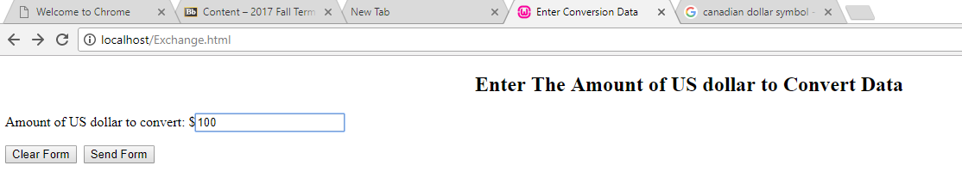

When we enter the value and we click Sent Form button, it will be process by exchange.php and we will have this result

